

22f-3104

DB Lab 8



March 22, 2024

fast cfd campus

**Task 1:**

**1. Display employees with their department number and name**

**Code :**

SELECT dept.deptno,dept.dname

FROM EMP

JOIN dept ON EMP.deptno=dept.deptno;

**Screen Shot:**

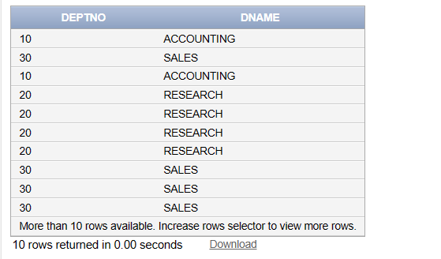

**2.Count the number of employees, working in each department. Display with**

**department name.**

**Code:**

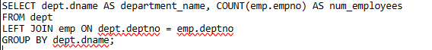

**Screen Shot:**

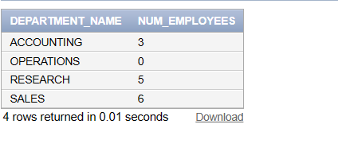

**3. How many employees are there, who are working in sales department.**

**Code:**

SELECT COUNT(emp.empno) AS num_employees_in_sales

FROM emp

JOIN dept ON emp.deptno = dept.deptno

WHERE dept.dname = 'SALES';

**Screen Shot:**

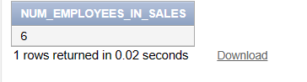

**4. Which department is having greater than or equal to 5 employees and display the**

**department names in ascending order?**

**Code:**

SELECT d.DNAME, emp_count.number_of_emps

FROM DEPT d

JOIN (

SELECT DEPTNO, COUNT(*) AS number_of_emps

FROM EMP GROUP BY DEPTNO

HAVING COUNT(*) >= 5

) emp_count ON d.DEPTNO = emp_count.DEPTNO

ORDER BY d.DNAME ASC;

**Screen Shot:**

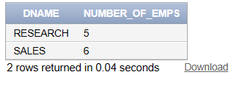

**5. List out the total salary of each department**

**Code:**

SELECT d.DNAME, SUM(e.SAL) AS Total_Salary

FROM DEPT d

JOIN EMP e ON d.DEPTNO = e.DEPTNO

GROUP BY d.DNAME;

**Screen Shot:**

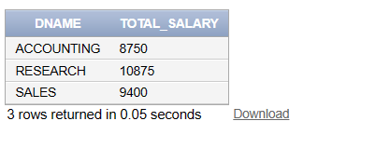

**6. Display employee details with all departments.**

**Code:**

SELECT e.*, d.*

FROM EMP e

CROSS JOIN DEPT d;

**Screen Shot:**

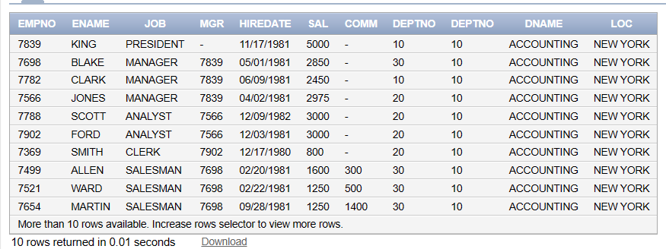

**7. Display the employee details working as mangers.**

**Code:**

SELECT e.*

FROM EMP e

JOIN EMP m ON e.MGR = m.EMPNO

WHERE e.JOB = 'MANAGER';

**Screen Shot:**

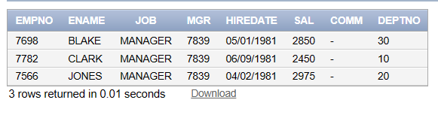

**8. List all departments, including those with no employees (outer join)**

**Code:**

SELECT d.DNAME, e.ENAME

FROM DEPT d

LEFT OUTER JOIN EMP e ON d.DEPTNO = e.DEPTNO;

**Screen Shot:**

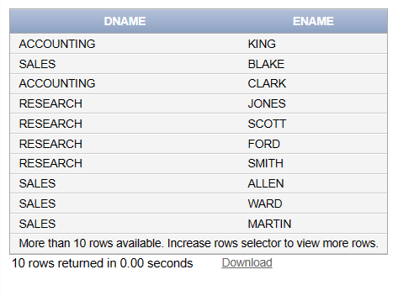

**9. Display the employee details who earn more than managers’ average salary**

**Code:**

SELECT e.*

FROM EMP e

JOIN EMP m ON e.MGR = m.EMPNO

JOIN (

SELECT AVG(SAL) AS AVG_Manager_Salary

FROM EMP

) avg_mgr ON e.SAL > avg_mgr.AVG_Manager_Salary;

**Screen Shot:**

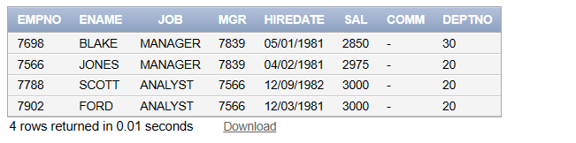

**10. Show the no. of employees working under research department.**

**Code:**

SELECT COUNT(*) AS NUMBER_OF_RESEARCH_EMPS

FROM EMP e

JOIN DEPT d ON e.DEPTNO=d.DEPTNO

WHERE d.DNAME='RESEARCH';

**Screen Shot:**

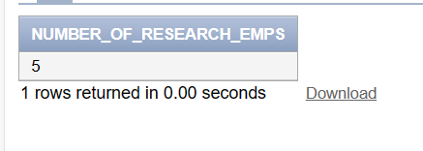

**11. Display the details of employees and their corresponding departments, excluding**

**employees with no department (inner join)**

**Code:**

SELECT e.*,d.DNAME

FROM EMP e

INNER JOIN DEPT d ON e.DEPTNO=d.DEPTNO;

**Screen Shot:**

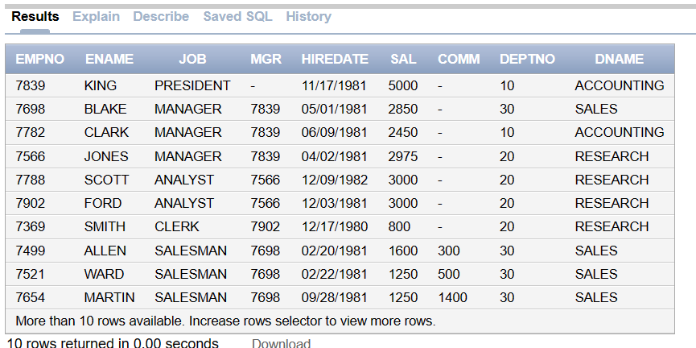

**12. Display employees with their department name, but also include departments**

**without employees (using outer join)**

**Code:**

SELECT e.*, d.DNAME

FROM DEPT d

RIGHT OUTER JOIN EMP e ON e.DEPTNO=d.DEPTNO;

**Screen Shot:**

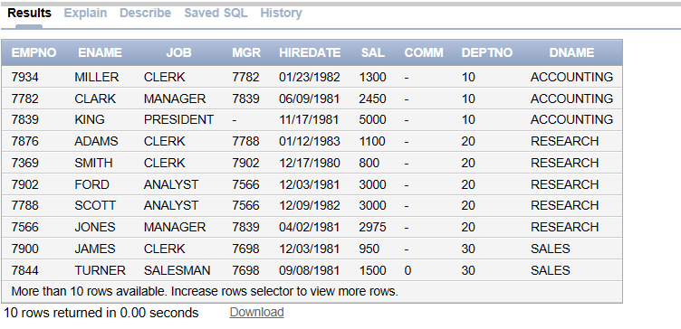

**13. Create two SELECT statements to retrieve a list of employees from two different**

**departments (e.g., Accounting and Sales). Use the UNION operator to combine**

**these lists into a single result set.**

**Code:**

SELECT * FROM EMP WHERE DEPTNO=(SELECT DEPTNO FROM DEPT WHERE DNAME='ACCOUNTING')

UNION

SELECT * FROM EMP WHERE DEPTNO=(SELECT DEPTNO FROM DEPT WHERE DNAME='SALES');

**Screen Shot:**

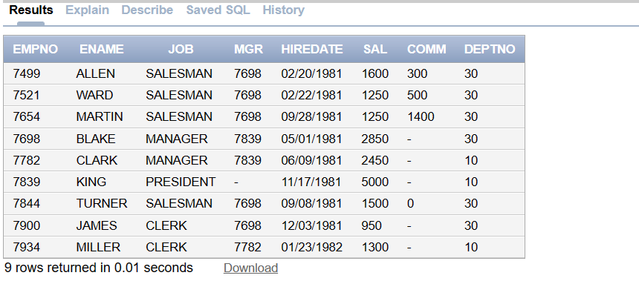

**14. Retrieve a list of employee IDs from the ‘emp’table who have not yet earned any commission. Use the MINUS operator to find the records.**

**Code :**

**Screen Shot:**

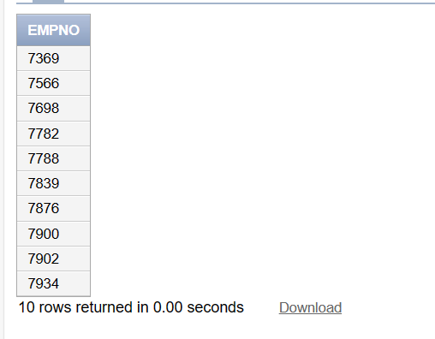

**15. Retrieve a list of employees who are assigned to both the ‘7839’ and ‘7968’;**

**Managers (MGR). Use the INTERSECT operator to find the common employees.**

**Code :**

SELECT EMPNO FROM EMP WHERE mgr=7839

INTERSECT

SELECT EMPNO FROM EMP WHERE mgr =7968

**Screen Shot:**

